**Name : Sharma Anish Ashok**

**Roll No : 11**

**SAP ID : 60003220045**

**Branch : Information Technology**

**Div : D**

**Batch : IT1**

**Experiment No. 1**

Write a program to swap two variables values with and without using third variables. Write algorithm and draw flowchart for the same.

**Aim :**

Swapping of two number with and without using third variable

**Algorithm :**

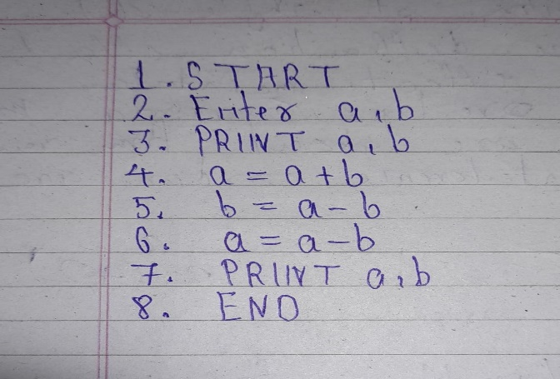

**Flowchart :**

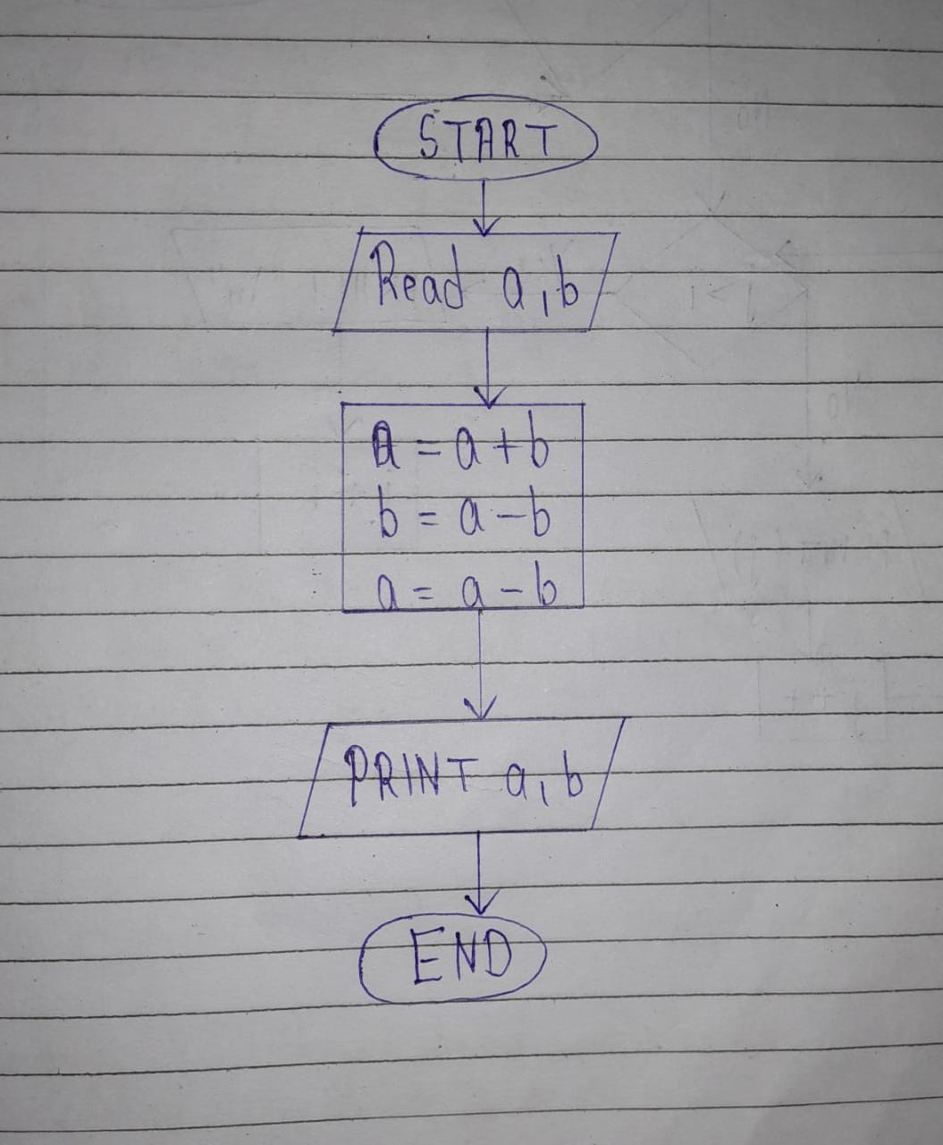

**Code :**

#include<stdio.h>

#include<conio.h>

void main()

{

int a,b;

clrscr();

printf("Enter a and b:\n");

scanf("%d %d",&a,&b);

a=a+b;

b=a-b;

a=a-b;

printf("\n After Swapping\n a and b is %d and %d respectively",a,b);

getch();

}

**Output :**

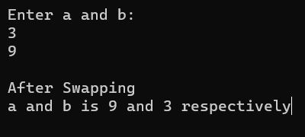

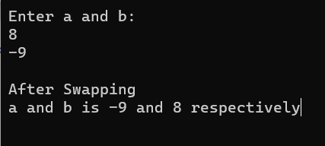

**Algorithm :**

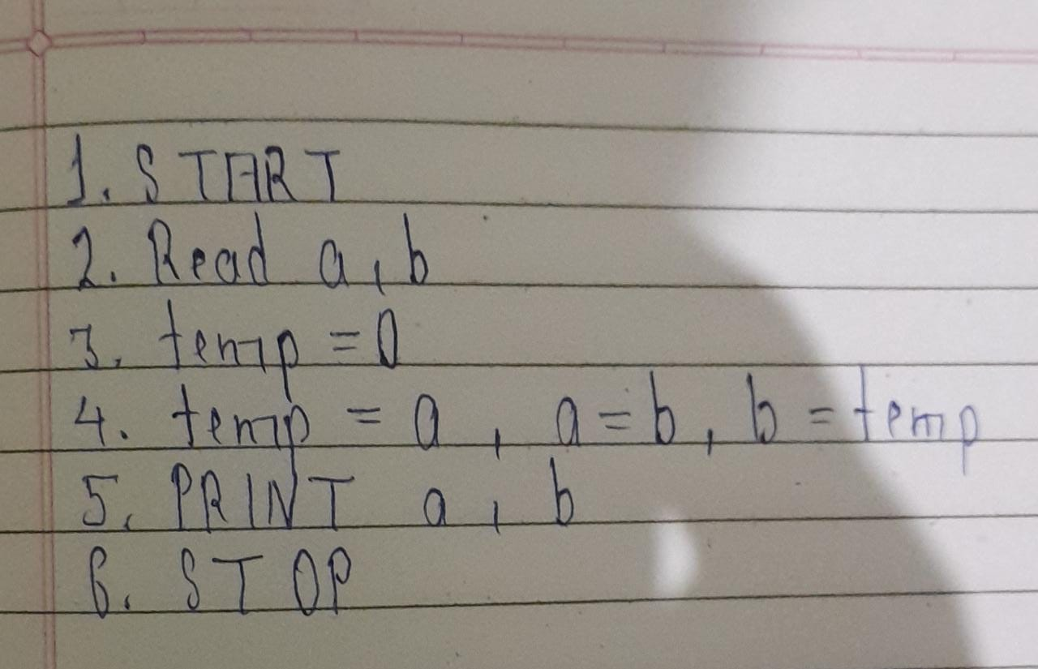

**Flowchart :**

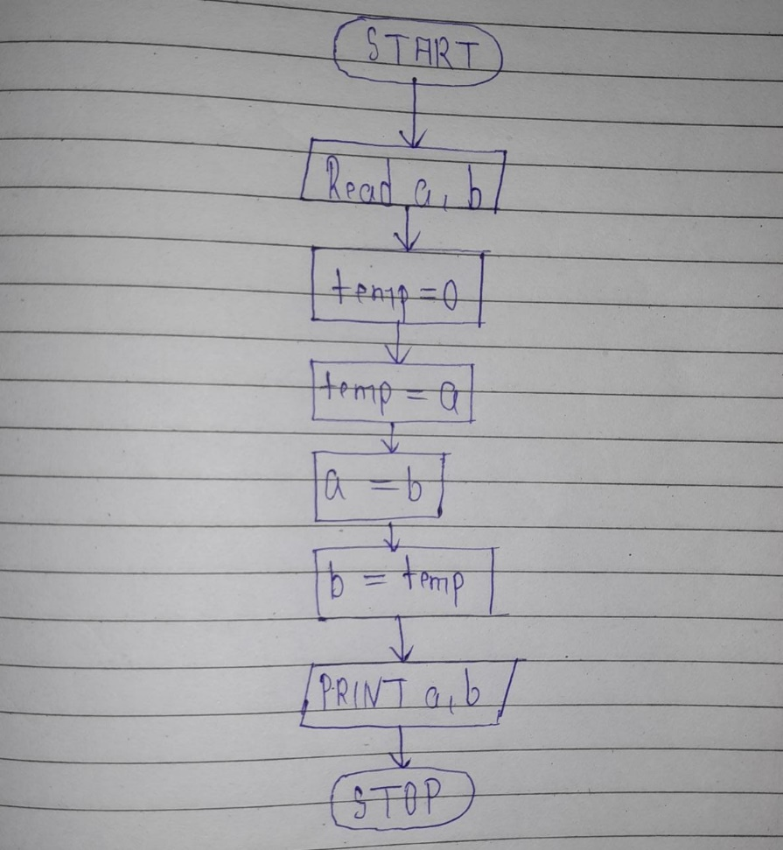

**code :**

#include<stdio.h>

#include<conio.h>

void main()

{

int a,b,temp=0;

//clrscr();

printf("Enter a and b:\n");

scanf("%d %d",&a,&b);

temp=a;

a=b;

b=temp;

printf("\nAfter swapping, a and b is %d and %d respectively",a,b);

getch();

} **output :**

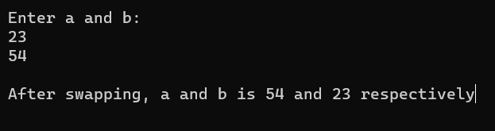

**Conclusion:**

We understand that the use of variable , operator and swapping of the number.

**Experiment No. 2**

Write a program to check odd or even number: (a) using modulus operator (b) using conditional operator.

**Aim:**

Check odd or even number

**A ) Using modulus operator**

**Code :**

#include<stdio.h>

#include<conio.h>

void main()

{

int num;

clrscr();

printf("Enter your number:\n");

scanf("%d",&num);

if(num%2==0)

printf("\n%d is EVEN NUMBER",num);

else

printf("\n%d is ODD NUMBER",num);

getch();

}

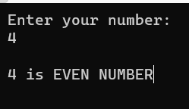**Output :**

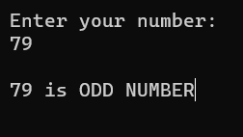

**B ) Using conditional operator**

**Code :**

#include<stdio.h>

#include<conio.h>

void main()

{

int num;

//clrscr();

printf("Enter your number:\n");

scanf("%d",&num);

(num%2==0)?printf("\n%d is EVEN NUMBER",num):printf("\n%d is ODD NUMBER",num);

getch();

}

**Output :**

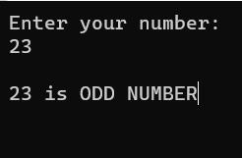

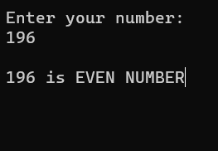

**Conclusion :**

We understand that the use of modulus operator and conditional or ternary operator in a above program.

**Experiment No. 3**

Design and develop a C program to read a year as an input and find whether it is leap year or not. Also consider the end of the centuries. Write algorithm and draw flowchart for the same.

**Aim :**

Check Leap year or not

**Algorithm :**

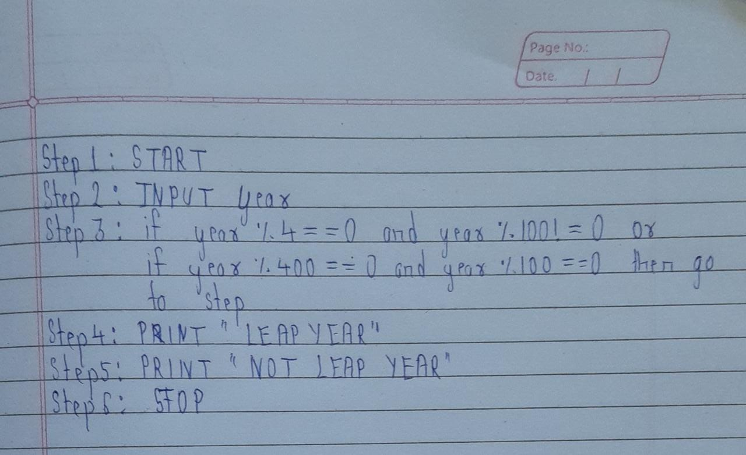

**Flowchart :**

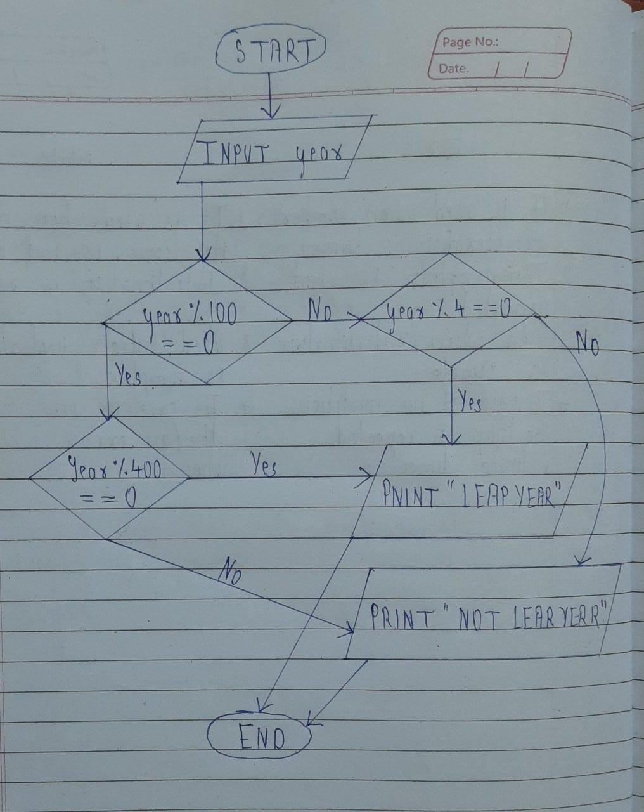

**Code :**

#include<stdio.h>

#include<conio.h>

void main()

{

int year;

//clrscr();

printf("Enter your year:\n");

scanf("%d",&year);

if((year%100==0 && year%400==0) || (year%100!=0 && year%4==0))

printf("\n%d is LEAP YEAR",year);

else

printf("\n%d is NOT LEAP YEAR",year);

getch();

}

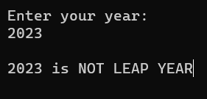**Output :**

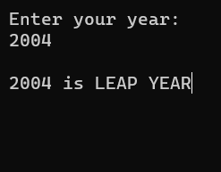

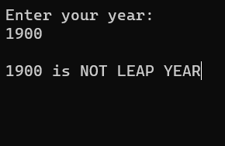

**Conclusion :**

We understand that the use of if else statement in above program.

**Experiment No. 4**

Write a C program to find the sum of individual digits of a 3-digit number.

**Aim** :

sum of individual digits of a 3-digit number

**Code :**

#include<stdio.h>

#include<conio.h>

void main()

{

int num,sum=0,rem;

//clrscr();

printf("Enter your number:\n");

scanf("%d",&num);

while(num>0)

{

rem=num%10;

sum+=rem;

num/=10;

}

printf("\nSum of individual digit number is %d",sum);

getch();

}

**Output:**

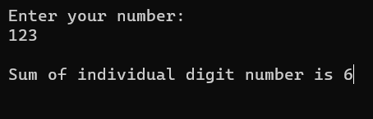 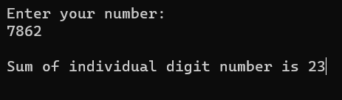

**Conclusion:**

We understand that the concept of while loop and some other operator.

**Experiment No. 5**

Design and develop a flowchart or an algorithm that takes three coefficients (a, b, and c) of a Quadratic equation (ax2 +bx+c=0) as input and compute all possible roots. Implement a C program for the developed flowchart/algorithm and execute the same to output the possible roots for a given set of coefficients with appropriate messages.

**Aim :**

To find roots of a Quadratic equation

**Algorithm :**

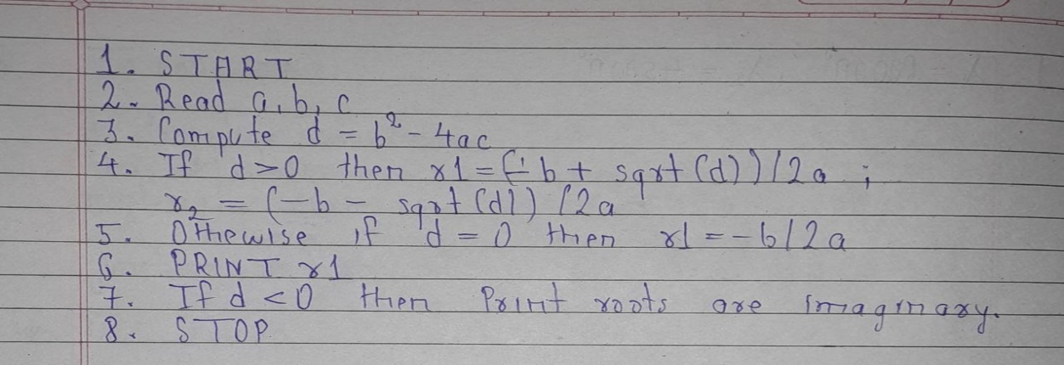

**Flowchart :**

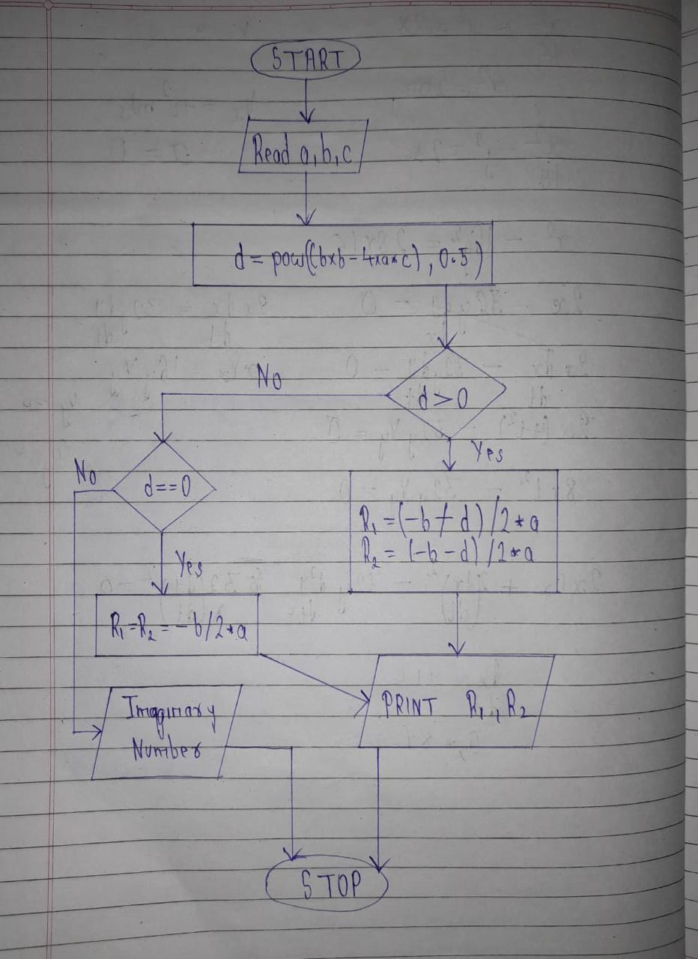

**Code :**

#include<stdio.h>

#include<conio.h>

#include<math.h>

void main()

{

double a,b,c,discriminant,root1,root2,real,img;

//clrscr();

//ax^2 + bx + c = 0

printf("Enter a value:\n");

scanf("%lf",&a);

printf("\nEnter b value:\n");

scanf("%lf",&b);

printf("\nEnter c value:\n");

scanf("%lf",&c);

discriminant=b*b-4*a*c;

if(discriminant==0)

{

root1=root2=-b/(2*a);

printf("\nRoots of an equation is %0.3lf",root1);

}

else if(discriminant>0)

{

root1=(-b+sqrt(discriminant)/(2*a));

root2=(-b-sqrt(discriminant)/(2*a));

printf("\nRoots of an equation is %0.3lf and %0.3lf",root1,root2);

}

else if(discriminant<0)

{

real=-b/(2*a);

img=sqrt(-(discriminant))/(2*a);

printf("\nRoots of an equation is %0.3lf + i%0.3lf and %0.3lf - i%0.3lf",real,img,real,img);

}

else

printf("\nEnter valid number");

getch();

}

**Output :**

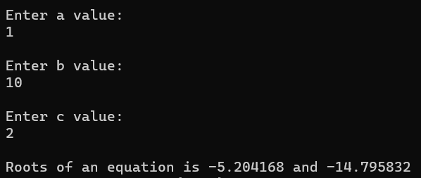

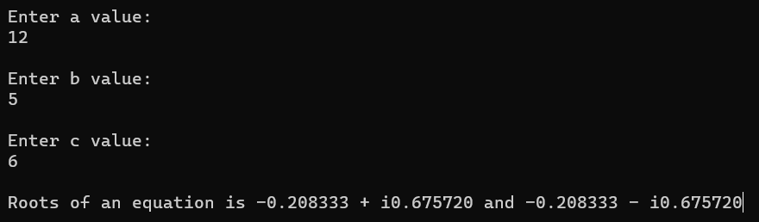

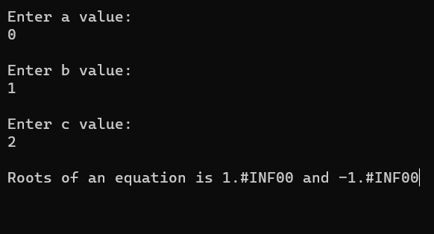

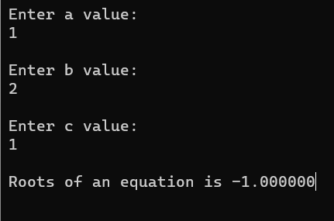

**Conclusion :**

We understand that some new library (math.h) in C programming along with how to code any problem related to maths subject.